Get started – Create a dataset
In this task you will setup the environment for the lab by creating a dataset.
Important: If you have already published the dataset in the Create a Power BI Dashboard lab, continue from the next task.
- In the Microsoft Edge browser window, in the Power BI service, in the Navigation pane, at the bottom, click Get Data.
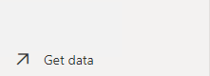
- In the Files tile, click Get.
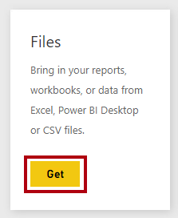
- Click the Local File tile.
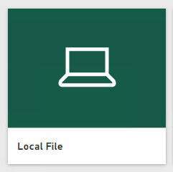
- In the Open window, navigate to the lab folder.
- Select the Sales Analysis.pbix file, and then click Open.
- If prompted to replace the dataset, click Replace.
- Task 3: Create the report
In this task you will create the Sales Exploration report.
- To open the Power BI Desktop, on the taskbar, click the Microsoft Power BI Desktop shortcut.
Important: If you already have Power BI Desktop open (from a previous lab), close that instance.

- To close the getting started window, at the top-left of the window, click X.

- If Power BI Desktop is not signed in to the Power BI service, at the top-right, click Sign In.

- Complete the sign in process using the same account used to sign in to the Power BI service.
- To save the file, click the File ribbon tab to open the backstage view.
- Select Save.
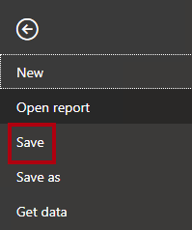
- In the Save As window, navigate to the D:\DA100\MySolution folder.
- In the File Name box, enter Sales Exploration.
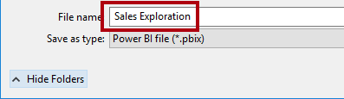
- To create a live connection to the Sales Analysis dataset, on the Home ribbon tab, from inside the Data group, click Power BI Datasets.
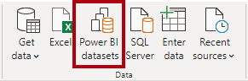
- In the Select a Dataset to Create a Report window, select the Sales Analysis dataset.
- Click Create.
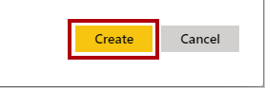
- Save the Power BI Desktop file.
You’ll now create four report pages, and on each page you’ll work with a different visual to analyze and explore data.
- Create a Scatter Chart
In this exercise you will create a scatter chart that can be animated.
- Task 1: Create an animated scatter chart
In this task you will create a scatter chart that can be animated.
- Rename Page 1 as Scatter Chart.
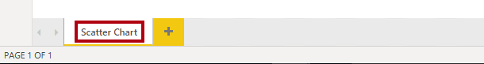
- Add a Scatter Chart visual to the report page, and then position and resize it so it fills the entire page.
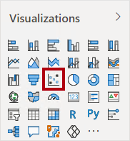

- Add the following fields to the visual wells:
The labs use a shorthand notation to reference a field. It will look like this: Reseller | Business Type. In this example, Reseller is the table name and Business Type is the field name.
  - Legend: Reseller | Business Type
  - X Axis: Sales | Sales
  - Y Axis: Sales | Profit Margin
  - Size: Sales | Quantity
  - Play Axis: Date | Quarter
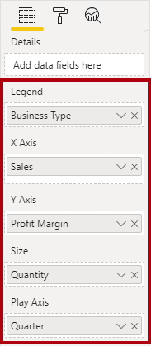
The chart can be animated when a field is added to the Play Axiswell.
- In the Filters pane, add the Product | Category field to the Filters On This Page well.
- In the filter card, filter by Bikes.
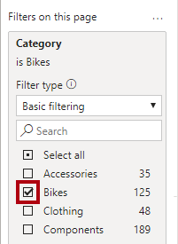
- To animate the chart, at the bottom left corner, click Play.
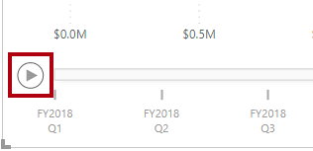
- Watch the entire animation cycle from FY2018 Q1 to FY2020 Q4.
The scatter chart allows understanding the measure values simultaneously: in this case, order quantity, sales revenue, and profit margin.
Each bubble represents a reseller business type. Changes in the bubble size reflect increased or decreased order quantities. While horizontal movements represent increases/decreases in sales revenue, and vertical movements represent increases/decreases in profitability.
- When the animation stops, click one of the bubbles to reveal its tracking over time.
- Hover the cursor over any bubble to reveal a tooltip describing the measure values for the reseller type at that point in time.
- In the Filters pane, filter by Clothing only, and notice that it produces a very different result.
- Save the Power BI Desktop file.
- Create a Forecast
In this exercise you will create a forecast to determine possible future sales revenue.
- Task 1: Create a forecast
In this task you will create a forecast to determine possible future sales revenue.
- Add a new page, and then rename the page to Forecast.
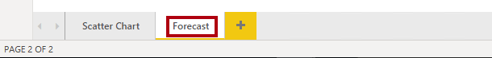
- Add a Line Chart visual to the report page, and then position and resize it so it fills the entire page.
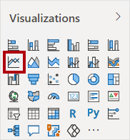
‎
- Add the following fields to the visual wells:
  - Axis: Date | Date
  - Values: Sales | Sales
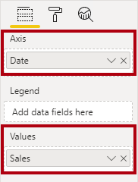
- In the Filters pane, add the Date | Year field to the Filters On This Page well.
- In the filter card, filter by two years: FY2019 and FY2020.
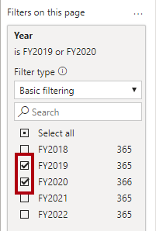
When forecasting over a time line, you will need at least two cycles (years) of data to produce an accurate and stable forecast.
- Add also the Product | Category field to the Filters On This Page well, and filter by Bikes.
- To add a forecast, beneath the Visualizations pane, select the Analytics pane.
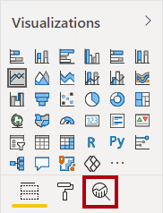
- Expand the Forecast section.

If the Forecast section is not available, it’s probably because the visual hasn’t been correctly configured. Forecasting is only available when two conditions are met: the axis has a single field of type date, and there’s only one value field.
- Click Add.
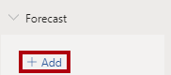
- Configure the following forecast properties:
  - Forecast length: 1 month
  - Confidence interval: 80%
  - Seasonality: 365
- Click Apply.
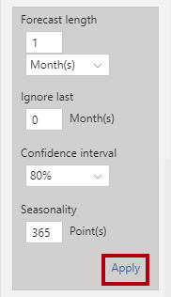
- In the line visual, notice that the forecast has extended one month beyond the history data.
The gray area represents the confidence. The wider the confidence, the less stable—and therefore the less accurate—the forecast is likely to be.
When you know the length of the cycle, in this case annual, you should enter the seasonality points. Sometimes it could be weekly (7), or monthly (30).
- In the Filters pane, filter by Clothing only, and notice that it produces a different result.
- Save the Power BI Desktop file.
- Work with a Decomposition Tree
In this exercise you will create a decomposition tree to explore the relationships between reseller geography and profit margin.
- Task 1: Work with a decomposition tree
In this task you will create a decomposition tree to explore the relationships between reseller geography and profit margin.
- Add a new page, and then rename the page to Decomposition Tree.
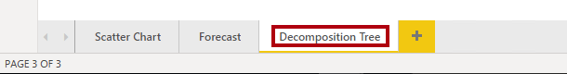
- On the Insert ribbon, from inside the AI Visuals group, click Decomposition Tree.
Tip: The AI visuals are also available in the Visualizations pane.
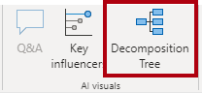
- Position and resize the visual so it fills the entire page.
- Add the following fields to the visual wells:
  - Analyze: Sales | Profit Margin
  - Explain By: Reseller | Geography (the entire hierarchy)
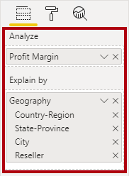
- In the Filters pane, add the Date | Year field to the Filters On This Page, and set the filter to FY2020.
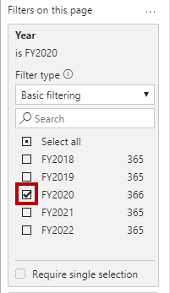
- In the decomposition tree visual, notice the root of the tree: Profit Margin at -0.94%
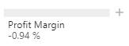
- Click the plus icon, and in the context menu, select High Value.
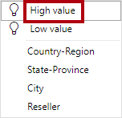
- Notice that the decision tree presents resellers, ordered from highest profit margin.
- To remove the level, at the top of visual, beside the Reseller label, click X.
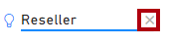
- Click the plus icon again, and then expand to the Country-Region level.
- Expand from the United States to the State-Province level.
- Use the down-arrow located at the bottom of the visual for State-Province, and then scroll to the lower profitable states.
- Notice that New York state has negative profitability.
- Expand from New York to the Reseller level.
- Notice that it is easy to isolate root cause.
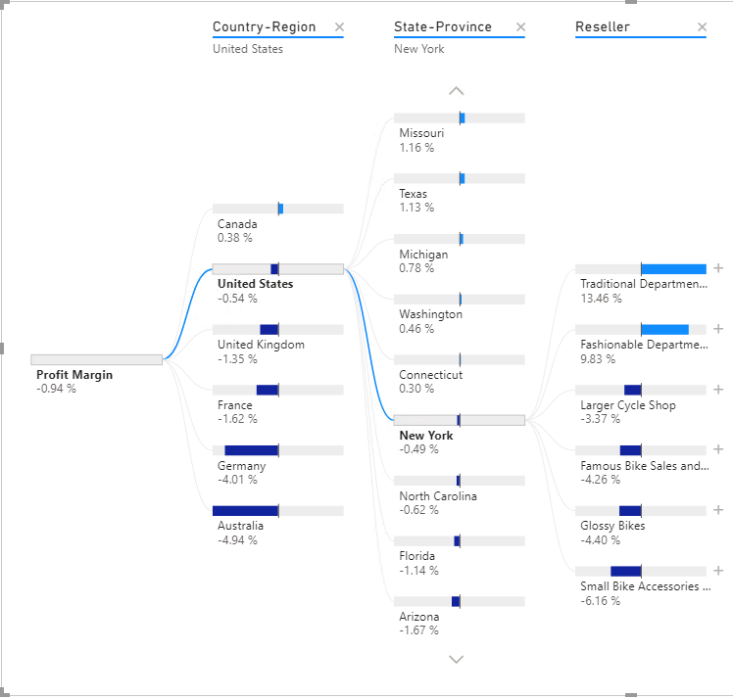
United States is not producing profit in FY2020. New York is one state that’s not achieving positive profit, and it’s due to four resellers paying less than standard costs for their goods.
- Save the Power BI Desktop file.
- Work with Key Influencers
In this exercise you will use the Key Influencers AI visual to determine what influences profitability within reseller business types and geography.
- Task 1: Work with key influencers
In this task you will use the Key Influencers AI visual to determine what influences profitability within reseller business types and geography.
- Add a new page, and then rename the page to Key Influencers.
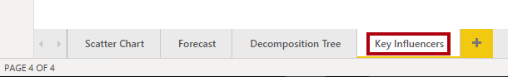
- On the Insert ribbon, from inside the AI Visuals group, click Key Influencers.
Tip: The AI visuals are also available in the Visualizations pane.
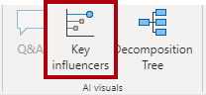
- Position and resize the visual so it fills the entire page.
- Add the following fields to the visual wells:
  - Analyze: Sales | Profit Margin
  - Explain By: Reseller | Business Type and Reseller | Geography (the entire hierarchy)
  - Expand By: Sales | Quantity
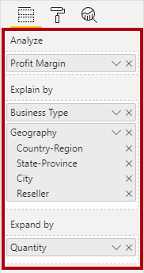
- At the top-left of the visual, notice that Key Influencers is in focus, and the specific influence is set to understand what includes profit margin to increase.
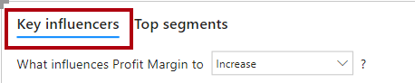
- Review the result, which is that the city of Bothel is more likely to increase.
- Modify the target to determine what influences profit margin to decrease.
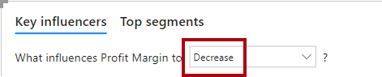
- Review the result.
- To detect segments, at the top-left, select Top Segments.
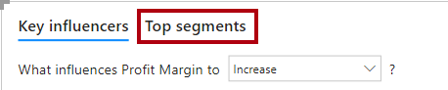
- Notice that the target is now to determine segments when profit margin is likely to be high.
- When the visual displays the segments (as circles), click one of them to reveal information about it.
- Review the segment results.
- Task 2: Finish up
In this task you will complete the lab.
- Select the Scatter Chart page.
- Save the Power BI Desktop file.
- To publish the file to your workspace, on the Home ribbon tab, from inside the Share group, click Publish.
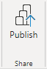
- Close Power BI Desktop.

